Safe Child Africa fearlessly protects children in Nigeria, including those accused of witchcraft. Thousands of children live on the streets in the Niger Delta region of Nigeria: many are victims of witchcraft accusations. No one should have a childhood like this.

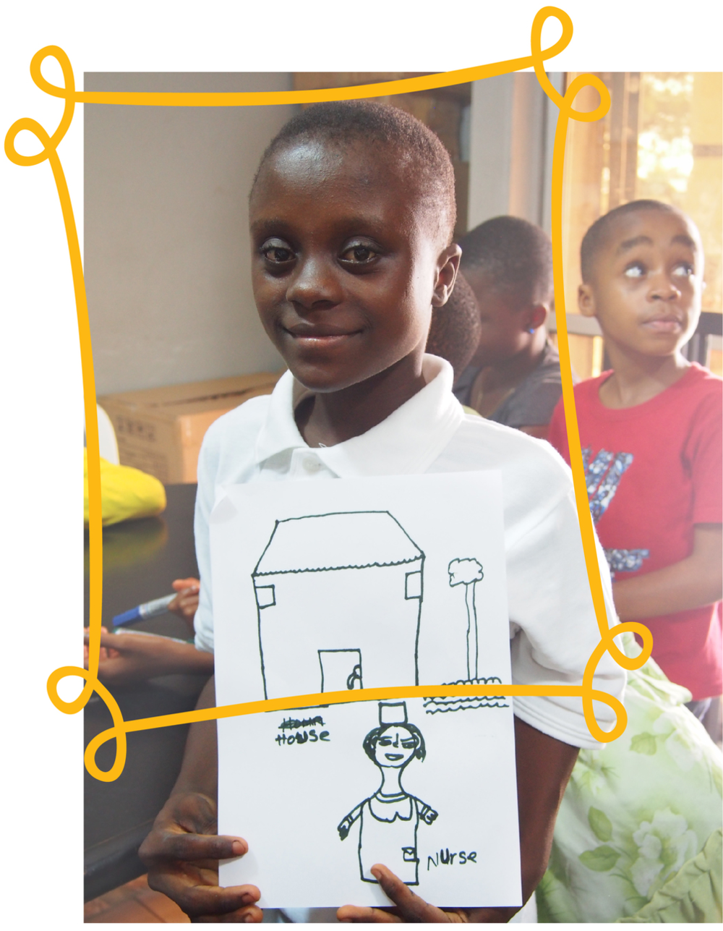
Meet Mercy
At 5 years old Mercy’s mum passed away. Her Dad soon left and she was left in the care of her uncle. Finding her new home cramped she preferred to regular explore and play outside. This behaviour was labelled suspicious, and with the death of her mum still recent accusations of witchcraft soon followed.
When a local pastor confirmed the suspicions Mercy was thrown out on the streets. A care home took Mercy in but threw her out once Mercy told them why she was on the streets. A kind passer-by started noticing Mercy sleeping regularly near and old stadium and alerted the Safe Child Africa team.
After giving Mercy immediate health care following her life on the streets, Mercy is now living in a caring foster home and surrounded by friends in new school. We’ve also reported Mercy’s case and providing legal aid to ensure those responsible for her abuse get brought to justice.
For 10 years Safe Child Africa has been committed to protecting many of the worlds most vulnerable children through providing immediate rescue and medical support, safe shelters, on going counselling and trauma relief as well as legal aid to bring abusers to justice. There is simply no child protection system for these children. We want to change this. Going forward we want to bring all our current projects together and more, including an emergency accommodation shelter, a street child outreach programme and creating a foster-care network to ensure each and every child in need are helped and can look forward to a better future.
Mums needed:
If Safe Child Africa didn’t exist these children would have no one to turn to. But thanks to the commitment of supporters we can be there to protect them. Our research has shown that many of our most committed supporters, passionate about child protection and child welfare, are mums! And we would love to harness the energy and potential these mums have in ensuring we can continue protecting children who need us by asking them to set up groups committed to regular fundraising through simple fun events with family and friends.
We’re not after mega-bucks, just regular donations we can count on to make sure we can be there for these children.
Our idea would be for each group to commit to organising a minimum of 4-6 events a year raising an expected minimum of £500 a year. The charity would support you through providing fundraising event ideas as well as fundraising advice and support. You would also be able to join an online community of fundraisers to share ideas and successes.

We would really love for as many mums as possible to join the Safe Child Africa team. Based on the idea presented please can you complete the following questionnaire to help us best shape the role profile for our volunteer fundraisers.
Please answer as fully as you can. We have done the survey in this format so that you can add your own comments wherever necessary. Thank you, thank you, and even more thanks for your time – we really appreciate it!
Questionnaire
1. Have you ever participated in a fundraising event/s? If so what did you do?
>>>
2. Do you feel that organising, as a group, 4-6 events annually is an achievable goal?
>>>
3. What type of events would you enjoy organising or think be successful in your group? (e.g Coffee mornings, cocktail nights, frock swaps, nearly new sales, etc)
>>>
4. How many friends do you have who you feel would be interested in being part of such a group?
>>>
5. Do you feel that £500 is a reasonable target amount to set per year?
>>>
6. Do you have any ideas for what we might call our Safe Child Africa Community Volunteer Groups?
>>>
7. Where would you suggest we advertise, promote or gain interest from mums in your local area for a volunteer fundraising group?
>>>
8. Have you attended any fundraising events in your local area run by community fundraisers? If so, what event? And did you enjoy it?
>>>

9. What materials/resources would be helpful or think you would need from us in order to feel supported, motivated as well as feeling confident in representing us?
>>>>
10. Do you think a Facebook community group would be the best way to share stories and ideas? If no, how would you prefer to be contacted?
>>>>
11. Can you think of any incentives for each group that would foster a sense of teamwork and/or encourage further fundraising? (e.g. prizes, personal recognition, time with the SCA team, letters from the children, charity clothing, parties, area meet ups, etc )
>>>>
12. After knowing a little more about Safe Child Africa and what we want to achieve would you consider being part of a Volunteer Fundraising network for us?
>>>>
Additional Comments: We would welcome your suggestions and thoughts.
>>>>

You can find out lots more information about Safe Child Africa on the website:
http://www.safechildafrica.org/
Please email your completed questionnaire to leeameliaj@gmail.com
Thank you for your time. If you would like further information about Safe Child Africa, would like to donate or become involved in any way, please get in touch with Amelia on 07450230127 or leeameliaj@gmail.com

